Table of contents

1. INTRODUCTION 2

I). REQUIRED 2

II). GIVEN 2

III). REFERENCES 2

IV). Member Sizes: 2

V). SOLUTION 2

2. ANALYSIS AND DESIGN APPROACH 3

I. STAAD MODEL: 3

II. LOADS AND LOAD COMBINATIONS: 3

III. ANALYSIS AND DESIGN: 3

IV. LOADS ON STRUCTURE: 3

3. 3D MODEL 4

4. STRUCTURAL GEOMETRY 5

5. MEMBER PROPERTIES 14

6. LOADINGS FOR STRUCTURE 17

A. BASIC LOAD CASES 17

BLC-1:- DEAD LOAD (DL) 17

BLC-2:- LIVE LOAD-FLOOR (LLF) 18

BLC-3:- LIVE LOAD-ROOF (LLR) 18

BLC-4:- SNOW LOAD (SN) 19

BLC-5:- WIND LOAD IN +X DIR. (WL+X) (As per Florida Building Code) 19

BLC-6:- WIND LOAD IN -X DIR. (WL-X) (As per Florida Building Code) 19

BLC-7:- WIND LOAD IN +Z DIR. (WL+Z) (As per Florida Building Code) 19

BLC-8:- WIND LOAD IN -Z DIR. (WL-Z) (As per Florida Building Code) 19

BLC-9:- EARTHQUAKE LOAD IN X DIR. (EX) (As per Florida Building Code) 21

BLC-10:- EARTHQUAKE LOAD IN Z DIR. (EZ) (As per Florida Building Code) 21

BLC-11:- EARTHQUAKE LOAD IN Y DIR. (EY) (As per Florida Building Code) 21

B. LOADING COMBINATIONS (As per Florida Building Code) 23

7. UNITY CHECKS FOR MEMBERS 27

8. CHECK FOR SERVICEABILITY 30

9. SUPPORTING NODES 31

10. Support Reaction for Foundation 32

11. BASE PLATE DESIGN 33

# INTRODUCTION

## REQUIRED

1. Structural Design calculation for “23633 Bishope AVE. Christmas –FL HOUSE”.

## GIVEN

1. SHIPPING STAMPED Drawing.
2. 3D Model.
3. Load and Design Data.

## REFERENCES

1. FLORIDA BUILDING CODE 7th Edition – 2020.
2. AISC 360-16 (Specification for Structural Steel Buildings).
3. ASCE 7-16 (Minimum Design Loads and Associated Criteria for Buildings and Other Structures).

***MATERIAL:***

* ***Structural Steel Sections – ASTM A572 Gr. 50.***

## Member Sizes:

**Member Sizes:**

1. Frame Members (W12x50)

2. Supporting Columns (W12x50)

3. Supporting Beams (W12x65)

4. Container- 40 ft (Assume HSS 5x5x0.375)

**Member Connections:**

Frame Members - Moment Connection.  
Column to Frame - Moment Connection.

## SOLUTION

Refer inputs, sketches, and calculations of loads and design of Steel members.

The analysis and design is carried out using STAAD Pro, 3D software.

# ANALYSIS AND DESIGN APPROACH

## STAAD MODEL:

The beams are modeled in STAAD Pro for 3D analysis. Fixed support condition is considered in analysis.

## LOADS AND LOAD COMBINATIONS:

Loads are categorized as Dead Load, Live Load, Snow Load, Wind load and Earthquake Load. The load calculation is presented on respective loading sheets.

The Loads are calculated as per Input data and factored as per Florida Building Code.

## ANALYSIS AND DESIGN:

1. The analysis method used is Load Resistance Factor Design (LRFD). The detailed structure analysis is presented in this calculation part.
2. Load is distributed along the span on main load bearing members as mentioned in the calculation.

## LOADS ON STRUCTURE:

See Pages “17” to “25”

# 3D MODEL

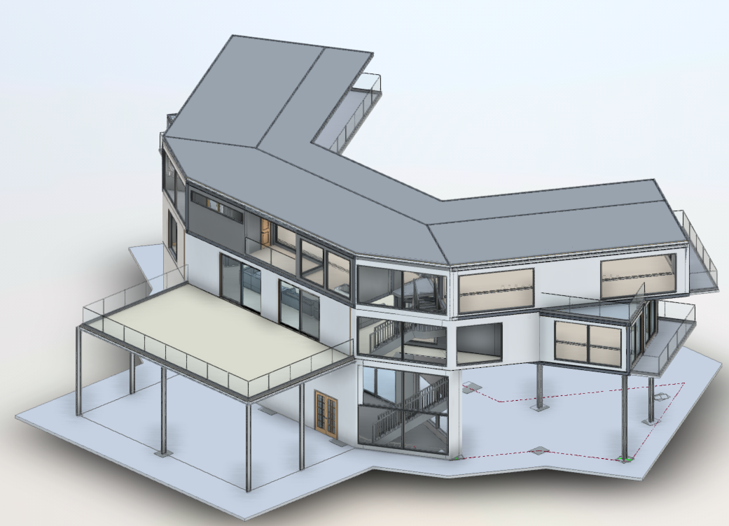

# STRUCTURAL GEOMETRY

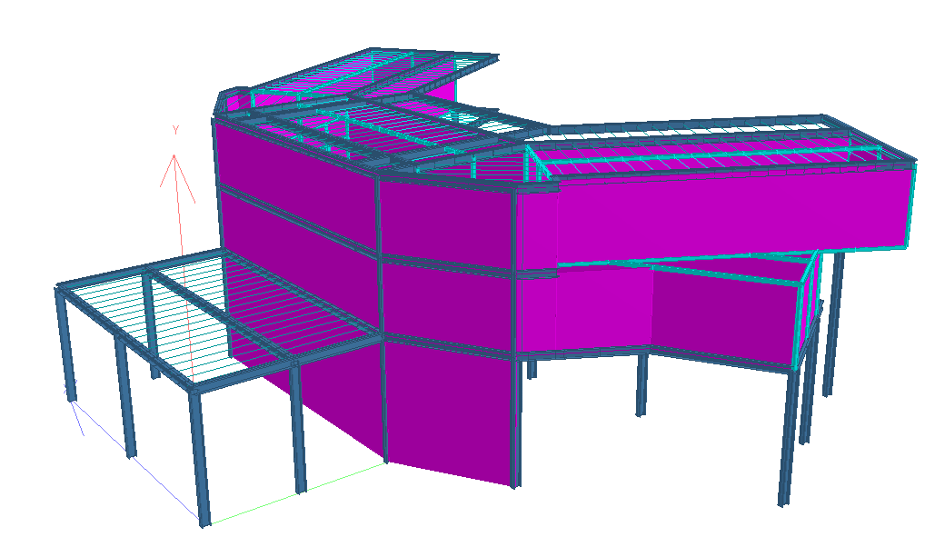

**3D- VIEW OF STRUCTURE**

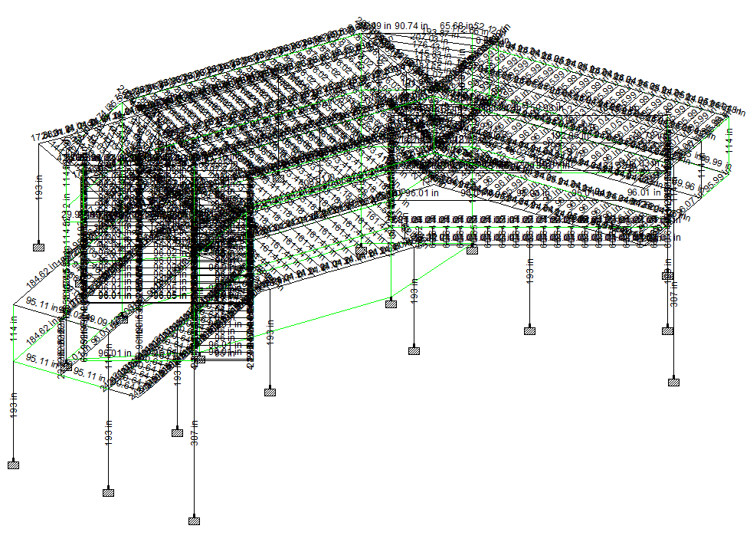 **DIMENSIONS – Isometric View**

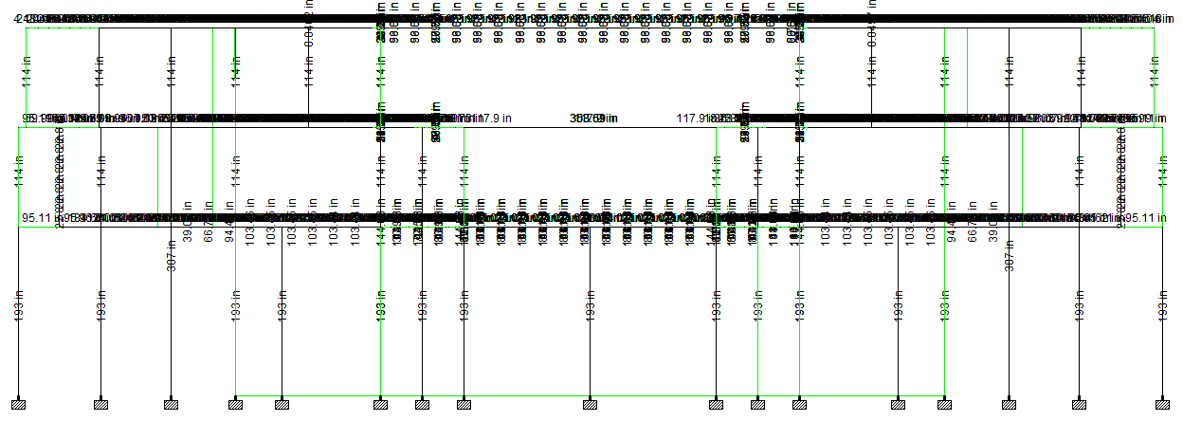

**DIMENSIONS – Front View**

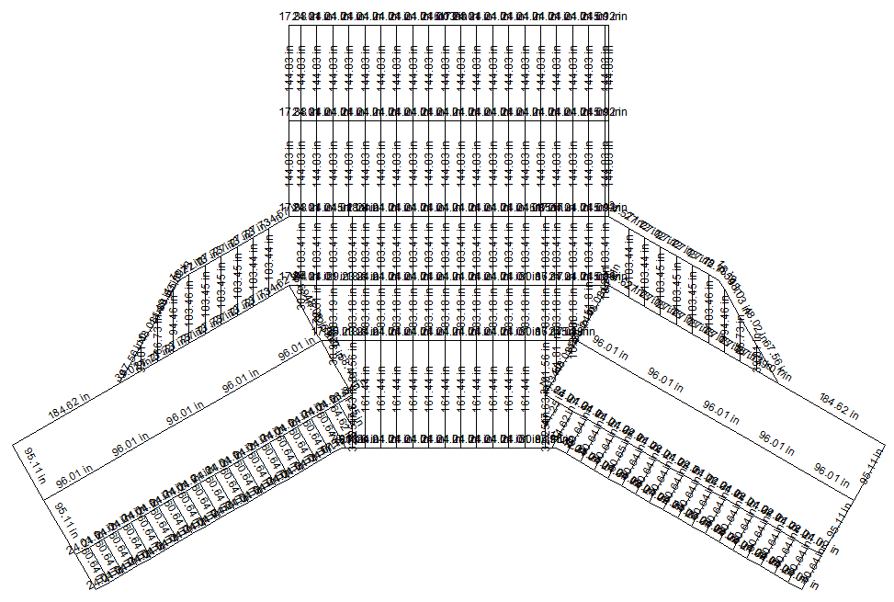

**DIMENSIONS – First Floor Plan View**

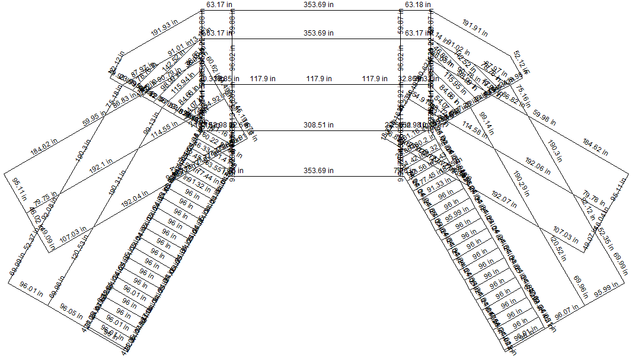

**DIMENSIONS – Second Floor Plan View**

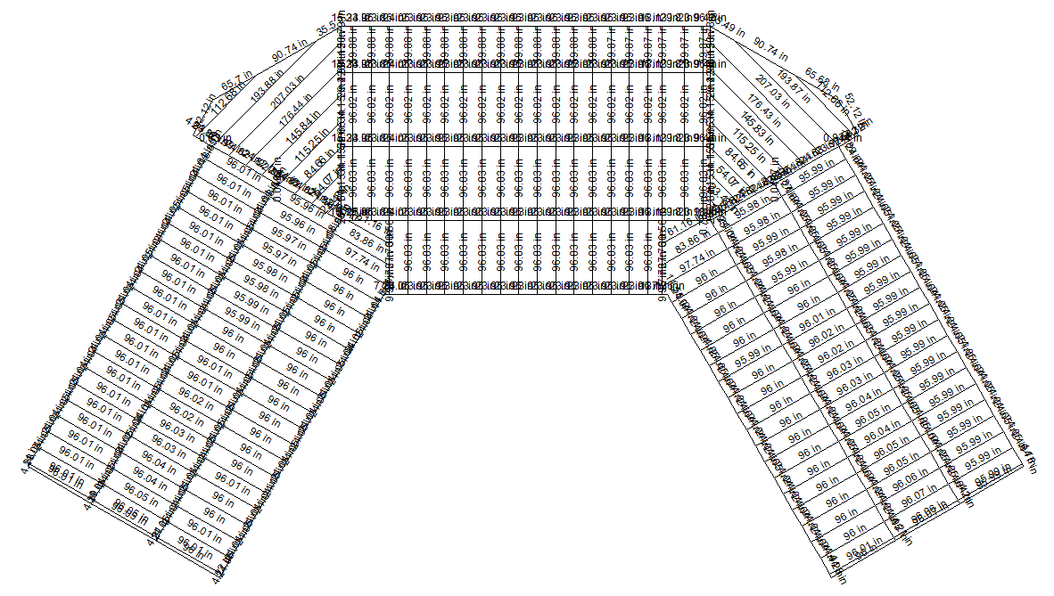

**DIMENSIONS – Roof Plan View**

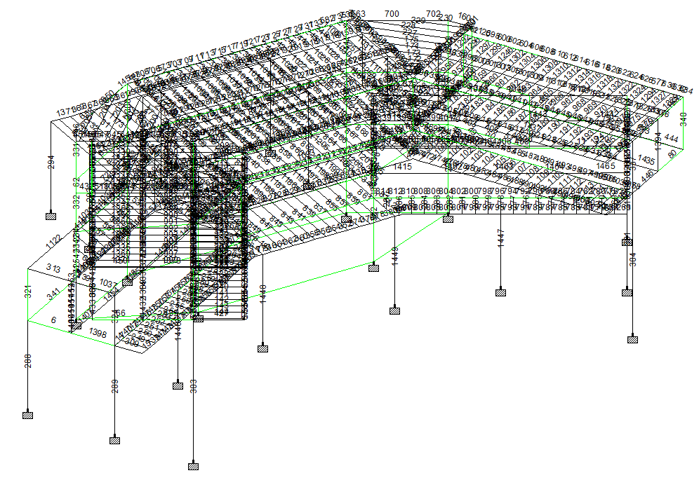

**Member Number – Isometric View**

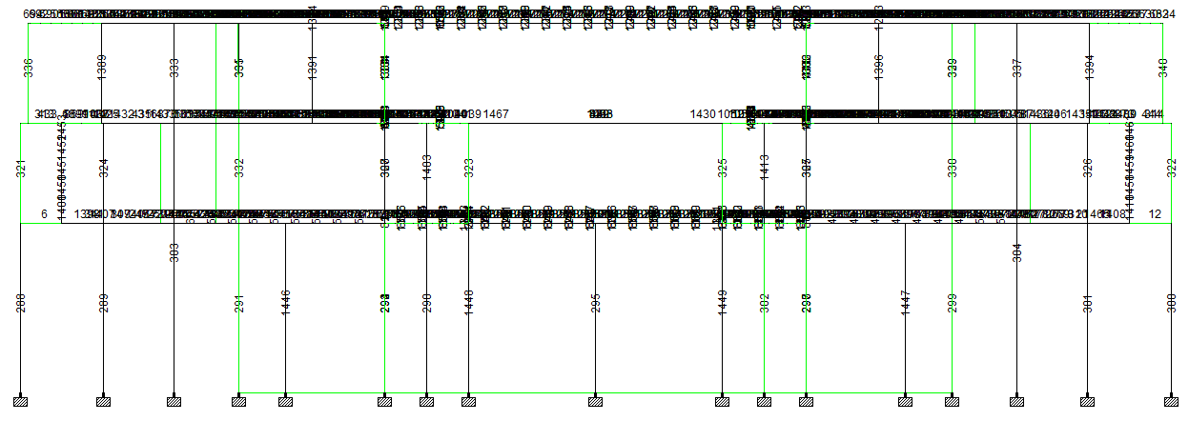

**Member Number – Front View**

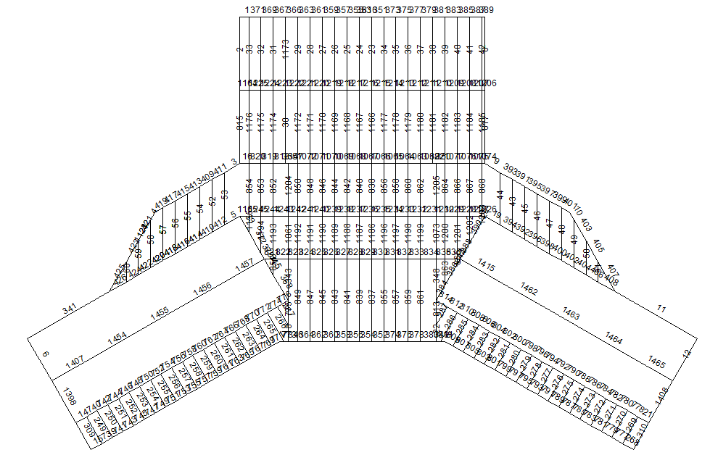

**Member Number – First Floor Plan View**

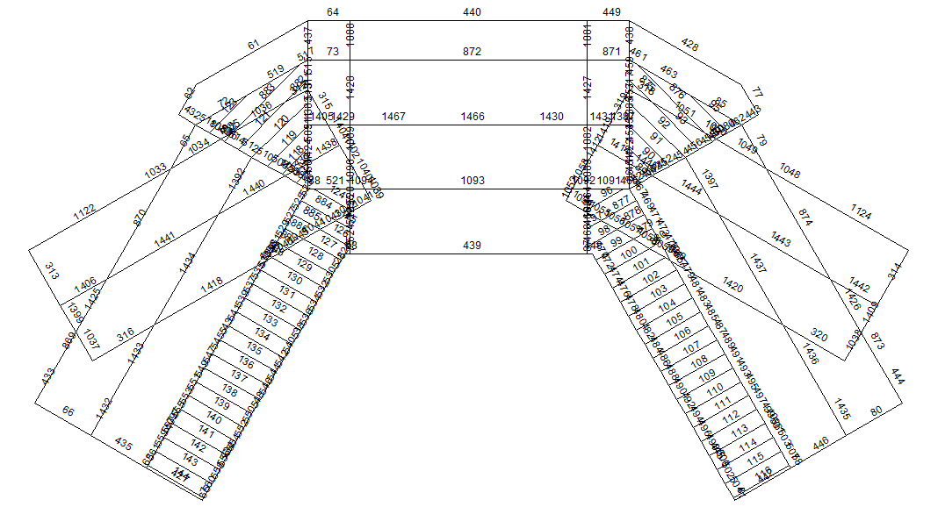

**Member Number – Second Floor Plan View**

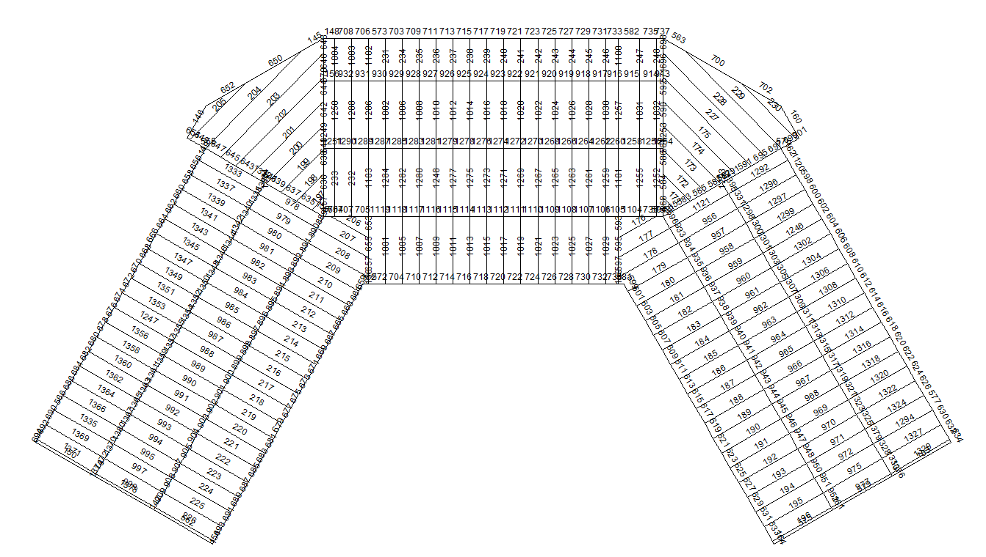

**Member Number – Roof Plan View**

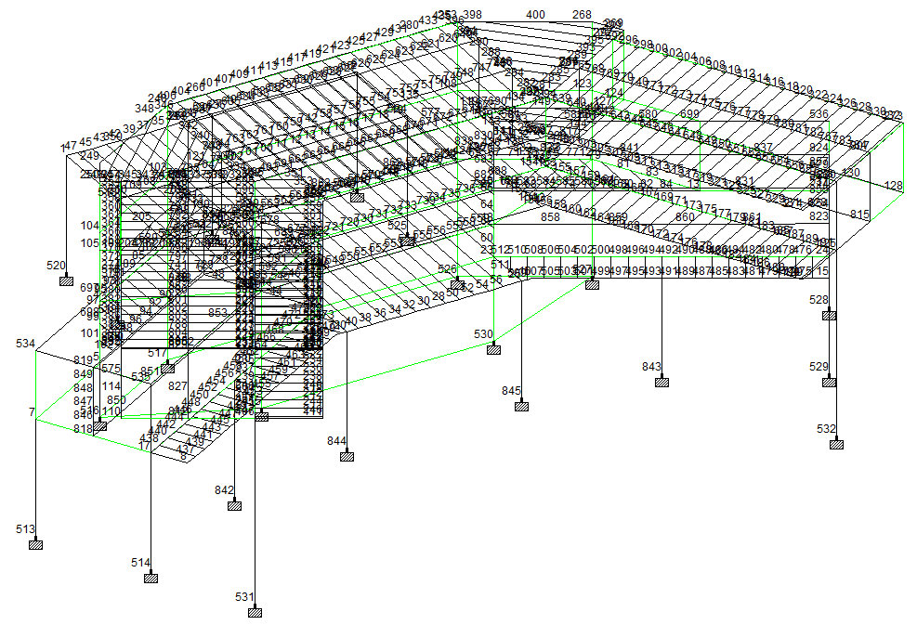

**Node Number – Isometric View**

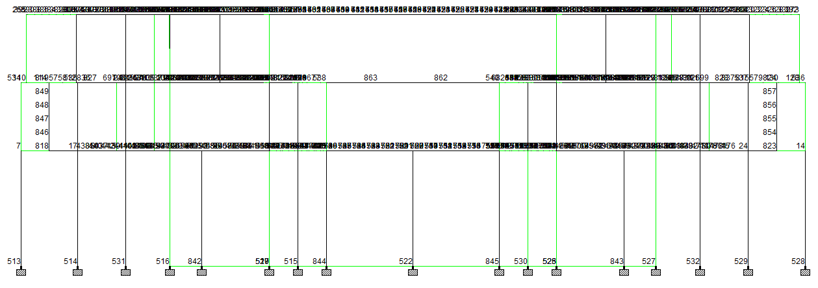

**Node Number – Front View**

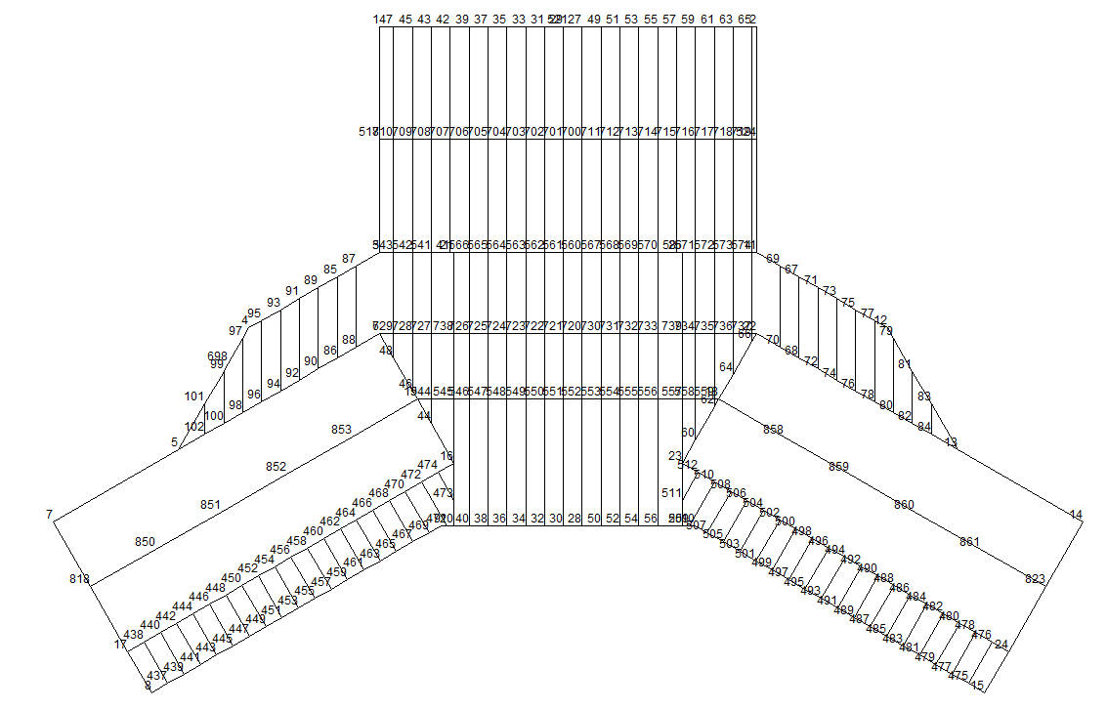

**Node Number – First Floor Plan View**

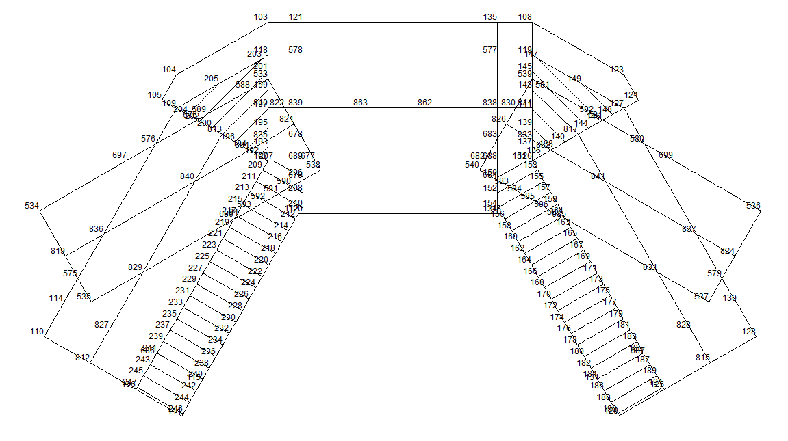

**Node Number – Second Floor Plan View**

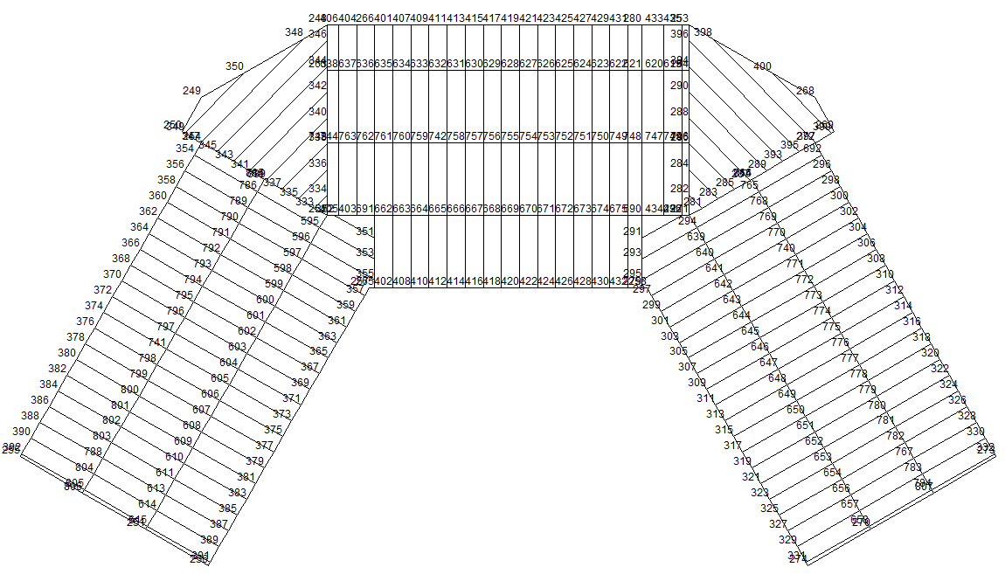

**Node Number – Roof Plan View**

# MEMBER PROPERTIES

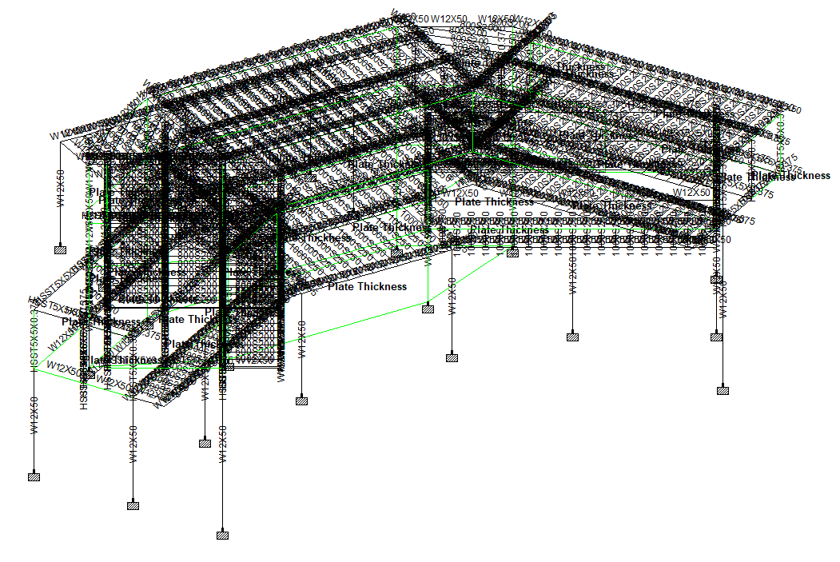

**Member Property – Isometric View**

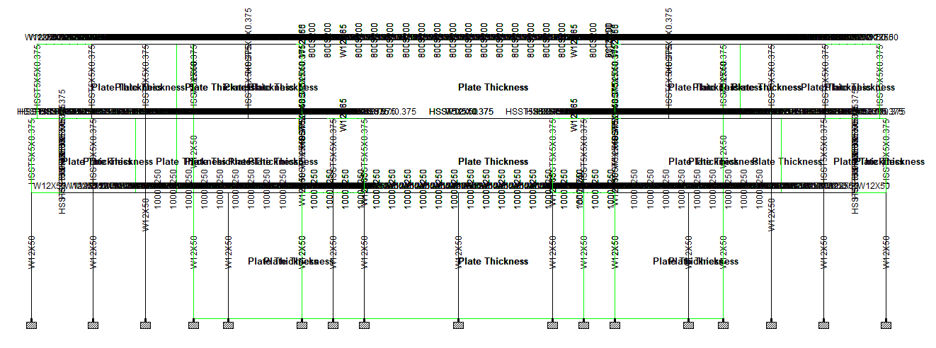

**Member Property – Front View**

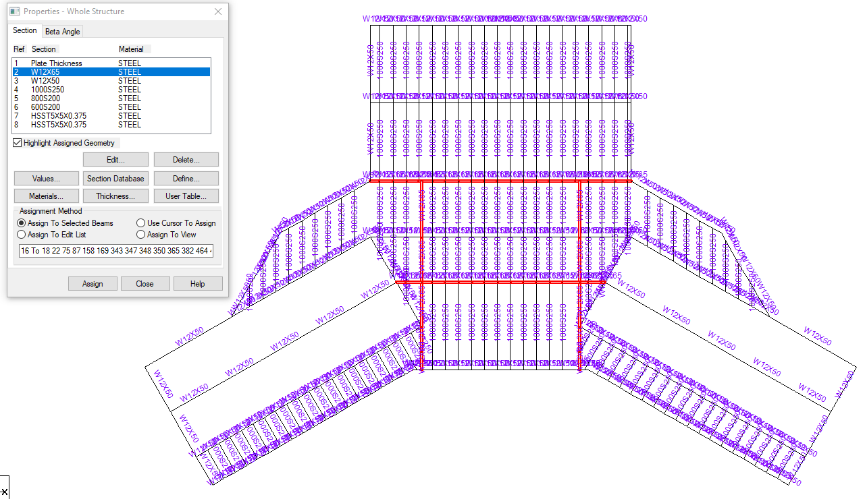

**Member Property – First Floor Plan View**

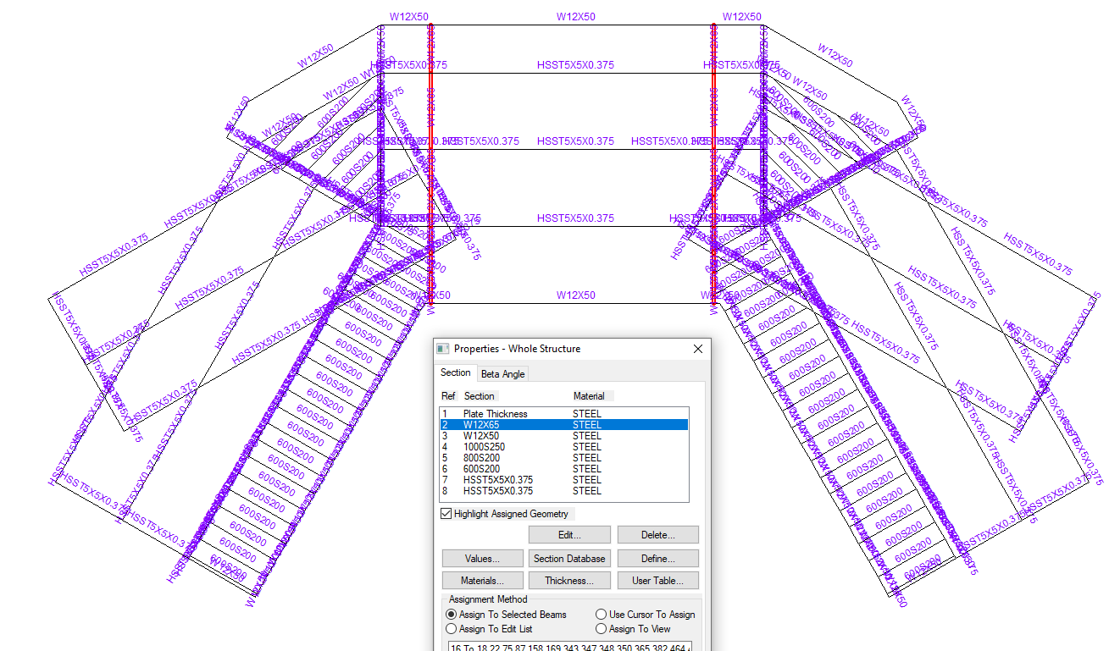

**Member Property – Second Floor Plan View**

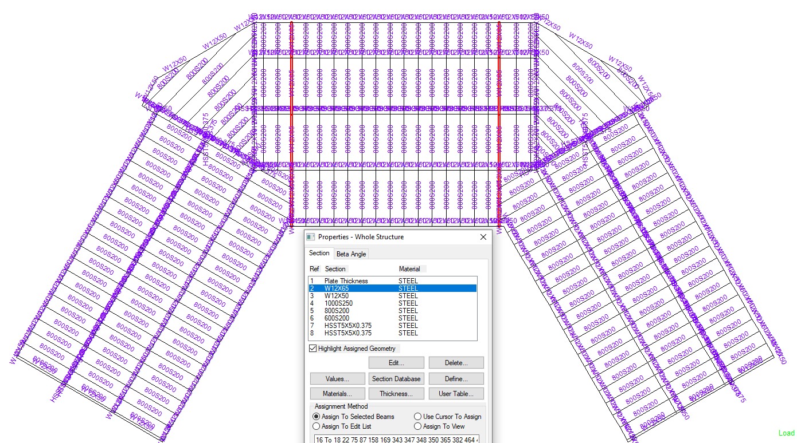

**Member Property – Roof Plan View**

# LOADINGS FOR STRUCTURE

## BASIC LOAD CASES

BASIC LOAD CASES

1. DEAD LOAD (DL)
2. LIVE LOAD-FLOOR (LLF)
3. LIVE LOAD-ROOF (LLR)
4. SNOW LOAD (SN)
5. WIND LOAD IN +X DIR. (WL+X)
6. WIND LOAD IN -X DIR. (WL-X)
7. WIND LOAD IN +Z DIR. (WL+Z)
8. WIND LOAD IN -Z DIR. (WL-Z)
9. EARTHQUAKE LOAD IN X DIR. (EX)
10. EARTHQUAKE LOAD IN X DIR. (EZ)
11. EARTHQUAKE LOAD IN Y DIR. (EY)

## DEAD LOAD (DL)

1. Self-weight of Structure. (Add graphically in Staad Model)
2. Dead Load = 10 PSF (Roof/Floor - Given)

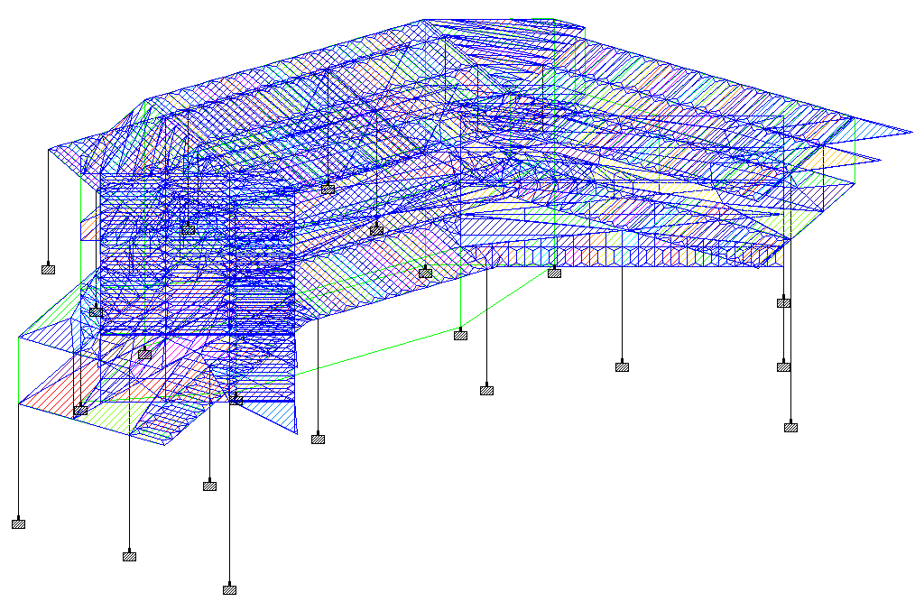

## LIVE LOAD-FLOOR (LLF)

Live Load = 40 PSF (Given)

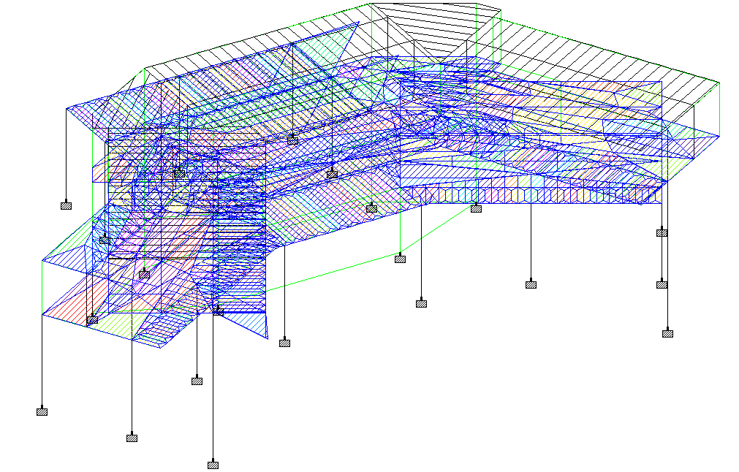

## LIVE LOAD-ROOF (LLR)

Live Load = 20 PSF (Given)

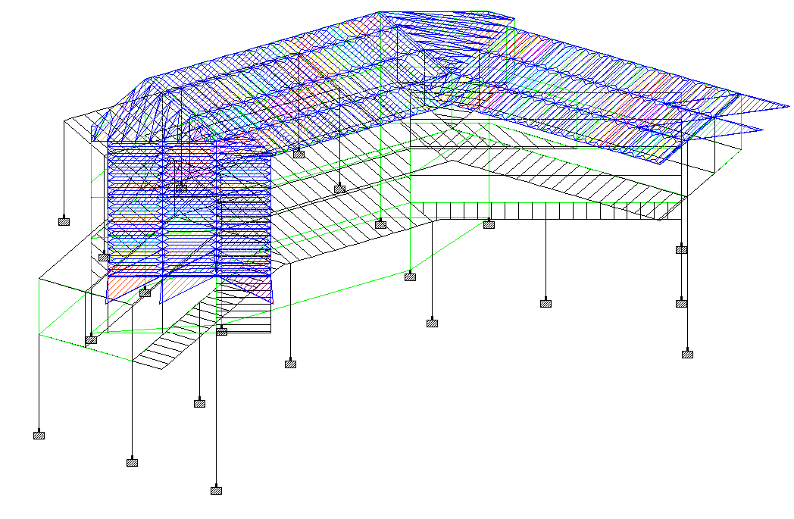

## SNOW LOAD (SN)



N/A

## WIND LOAD IN +X DIR. (WL+X) (As per Florida Building Code)

## WIND LOAD IN -X DIR. (WL-X) (As per Florida Building Code)

## WIND LOAD IN +Z DIR. (WL+Z) (As per Florida Building Code)

## WIND LOAD IN -Z DIR. (WL-Z) (As per Florida Building Code)

Ultimate wind speed, Vutm = 140 MPH (as per Figure 1609.3(1), FBC)

Vasd = 108 MPH (as per Table 1609.3.1, FBC)

Exposure Category = B (given)

Risk Category = II (as per Florida Building Code)

Net Pressure Coefficient, Cnet = 1.28 (as per Table 1609.3.2, FBC)

Exposure Coefficient (Kz) = 0.73 (as per Table 26.10-1 ASCE 7-16)

Topographic Factor (Kzt) = 1.0 (as per 26.8.2 ASCE 7-16)

Wind Pressure (Pnet) = 0.00256* V2*Kz*Cnet*Kzt (as per 1609.6.2, FBC)

= 27.9 PSF or ~ **28 PSF**

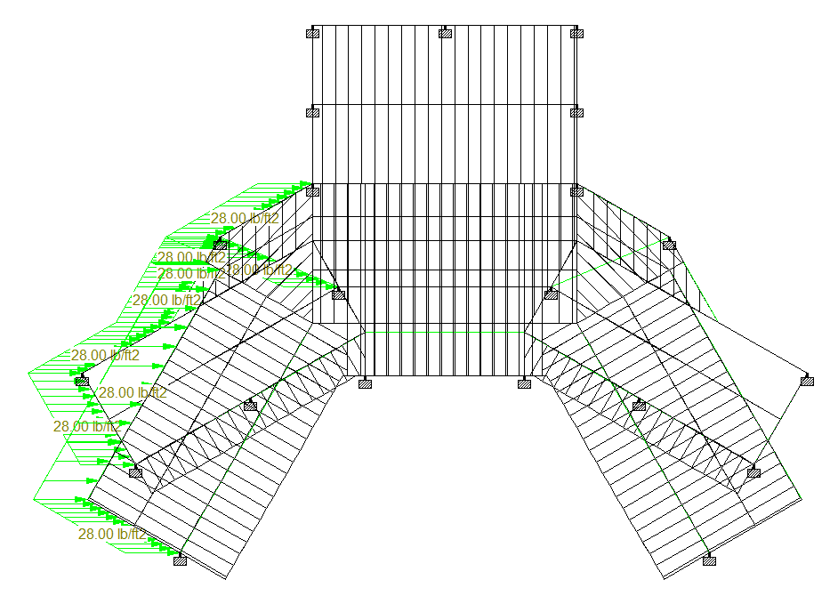

**Wind Load in +X Dir.**

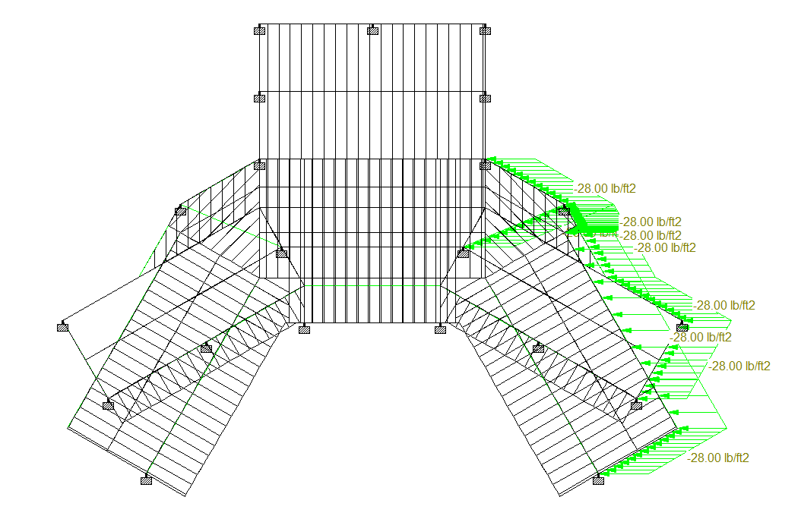

**Wind Load in -X Dir.**

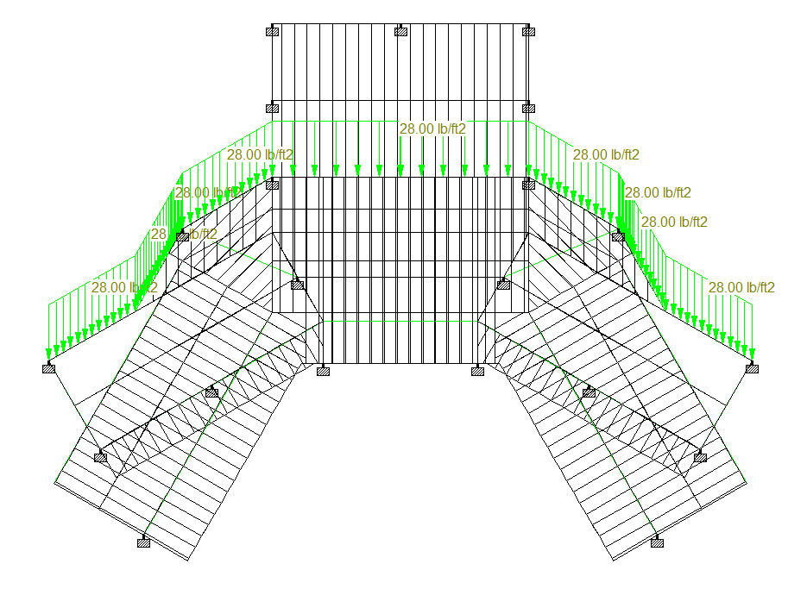

**Wind Load in +Z Dir.**

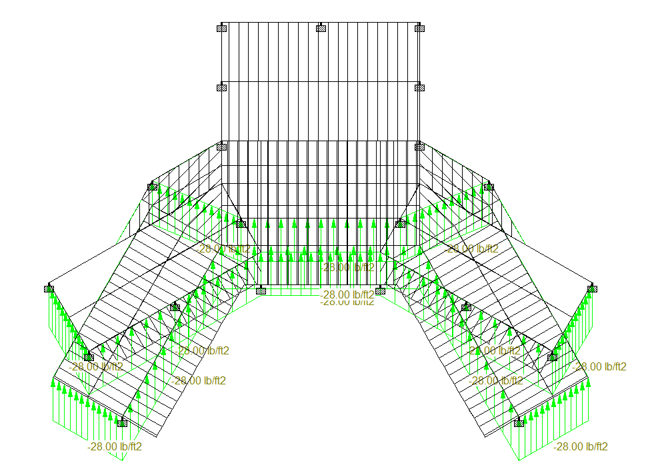

**Wind Load in -Z Dir.**

## EARTHQUAKE LOAD IN X DIR. (EX) (As per Florida Building Code)

## EARTHQUAKE LOAD IN Z DIR. (EZ) (As per Florida Building Code)

## EARTHQUAKE LOAD IN Y DIR. (EY) (As per Florida Building Code)

Site Class = D

Risk Category = II (Given)

Importance Factor (I) = 1.0

Site Coefficient (Fa) = 1.6

Spectral Response Acceleration (SMS) = 0.097

Spectral Acceleration parameter (SDS) = 0.065

Lateral seismic base shear force ’V’ = 0.30 x SDS x I x W

Effective Seismic Weight ‘W’ = DL + 0.5 LL

Let, A = 0.30 x SDS x I = **0.0195**

So, Earthquake load = A x (DL + 0.5 LL)

And, Earthquake load in Vertical Direction = 2/3 of Lateral Load.

**NOTE: -** 1. Seismic Load due to self-weight of structure is applied graphically in Staad model with seismic Coefficient (A) in Horizontal Direction.  
2. Location: 23633 Bishop Ave, Christmas, FL 32709, USA (Latitude, Longitude: 28.526659, -81.01832399999999)  
<https://hazards.atcouncil.org/>

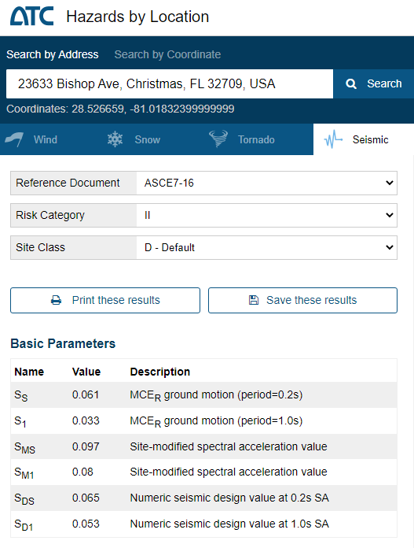

## LOADING COMBINATIONS (As per Florida Building Code)

1. **For Strength Check**

LOAD COMB 101 DL

1 1.4

LOAD COMB 102 DL+LLF+LLR

1 1.2 2 1.6 3 0.5

LOAD COMB 103 DL+LLF+SN

1 1.2 2 1.6 4 0.5

LOAD COMB 104 DL+LLR+LLF

1 1.2 3 1.6 2 0.5

LOAD COMB 105 DL+SN+LLF

1 1.2 4 1.6 2 0.5

LOAD COMB 106 DL+LLR+W(+X)

1 1.2 3 1.6 5 0.5

LOAD COMB 107 DL+LLR+W(-X)

1 1.2 3 1.6 6 0.5

LOAD COMB 108 DL+LLR+W(+Z)

1 1.2 3 1.6 7 0.5

LOAD COMB 109 DL+LLR+W(-Z)

1 1.2 3 1.6 8 0.5

LOAD COMB 110 DL+SN+W(+X)

1 1.2 4 1.6 5 0.5

LOAD COMB 111 DL+SN+W(-X)

1 1.2 4 1.6 6 0.5

LOAD COMB 112 DL+SN+W(+Z)

1 1.2 4 1.6 7 0.5

LOAD COMB 113 DL+SN+W(-Z)

1 1.2 4 1.6 8 0.5

LOAD COMB 114 DL+W(+X)+LLF+LLR

1 1.2 5 1.0 2 0.5 3 0.5

LOAD COMB 115 DL+W(-X)+LLF+LLR

1 1.2 6 1.0 2 0.5 3 0.5

LOAD COMB 116 DL+W(+Z)+LLF+LLR

1 1.2 7 1.0 2 0.5 3 0.5

LOAD COMB 117 DL+W(-Z)+LLF+LLR

1 1.2 8 1.0 2 0.5 3 0.5

LOAD COMB 118 DL+W(+X)+LLF+SN

1 1.2 5 1.0 2 0.5 4 0.5

LOAD COMB 119 DL+W(-X)+LLF+SN

1 1.2 6 1.0 2 0.5 4 0.5

LOAD COMB 120 DL+W(+Z)+LLF+SN

1 1.2 7 1.0 2 0.5 4 0.5

LOAD COMB 121 DL+W(-Z)+LLF+SN

1 1.2 8 1.0 2 0.5 4 0.5

LOAD COMB 122 DL+E(+X)+LLF+SN

1 1.2 9 1.0 2 0.5 4 0.7

LOAD COMB 123 DL+E(-X)+LLF+SN

1 1.2 9 -1.0 2 0.5 4 0.7

LOAD COMB 124 DL+E(+Z)+LLF+SN

1 1.2 10 1.0 2 0.5 4 0.7

LOAD COMB 125 DL+E(-Z)+LLF+SN

1 1.2 10 -1.0 2 0.5 4 0.7

LOAD COMB 126 DL+E(+Y)+LLF+SN

1 1.2 11 1.0 2 0.5 4 0.7

LOAD COMB 127 DL+E(-Y)+LLF+SN

1 1.2 11 -1.0 2 0.5 4 0.7

LOAD COMB 128 DL+W(+X)

1 0.9 5 1.0

LOAD COMB 129 DL+W(-X)

1 0.9 6 1.0

LOAD COMB 130 DL+W(+Z)

1 0.9 7 1.0

LOAD COMB 131 DL+W(-Z)

1 0.9 8 1.0

LOAD COMB 132 DL+E(+X)

1 0.9 9 1.0

LOAD COMB 133 DL+E(-X)

1 0.9 9 -1.0

LOAD COMB 134 DL+E(+Z)

1 0.9 10 1.0

LOAD COMB 135 DL+E(-Z)

1 0.9 10 -1.0

LOAD COMB 136 DL+E(+Y)

1 0.9 11 1.0

LOAD COMB 137 DL+E(-Y)

1 0.9 11 -1.0

1. **For** **Serviceability**

LOAD COMB 201 DL

1 1.0

LOAD COMB 202 DL+LLR

1 1.0 3 1.0

LOAD COMB 203 DL+SN

1 1.0 4 1.0

LOAD COMB 204 DL+LLF+LLR

1 1.0 2 0.75 3 0.75

LOAD COMB 205 DL+LLF+SN

1 1.0 2 0.75 4 0.75

LOAD COMB 206 DL+W(+X)

1 1.0 5 0.6

LOAD COMB 207 DL+W(-X)

1 1.0 6 0.6

LOAD COMB 208 DL+W(+Z)

1 1.0 7 0.6

LOAD COMB 209 DL+W(-Z)

1 1.0 8 0.6

LOAD COMB 210 DL+E(+X)

1 1.0 9 0.7

LOAD COMB 211 DL+E(-X)

1 1.0 9 -0.7

LOAD COMB 212 DL+E(+Z)

1 1.0 10 0.7

LOAD COMB 213 DL+E(-Z)

1 1.0 10 -0.7

LOAD COMB 214 DL+E(+Y)

1 1.0 11 0.7

LOAD COMB 215 DL+E(-Y)

1 1.0 11 -0.7

LOAD COMB 216 DL+W(+X)+LLF+LLR

1 1.0 5 0.45 2 0.75 3 0.75

LOAD COMB 217 DL+W(-X)+LLF+LLR

1 1.0 6 0.45 2 0.75 3 0.75

LOAD COMB 218 DL+W(+Z)+LLF+LLR

1 1.0 7 0.45 2 0.75 3 0.75

LOAD COMB 219 DL+W(-Z)+LLF+LLR

1 1.0 8 0.45 2 0.75 3 0.75

LOAD COMB 220 DL+W(+X)+LLF+SN

1 1.0 5 0.45 2 0.75 4 0.75

LOAD COMB 221 DL+W(-X)+LLF+SN

1 1.0 6 0.45 2 0.75 4 0.75

LOAD COMB 222 DL+W(+Z)+LLF+SN

1 1.0 7 0.45 2 0.75 4 0.75

LOAD COMB 223 DL+W(-Z)+LLF+SN

1 1.0 8 0.45 2 0.75 4 0.75

LOAD COMB 224 DL+E(+X)+LLF+SN

1 1.0 9 0.525 2 0.75 4 0.75

LOAD COMB 225 DL+E(-X)+LLF+SN

1 1.0 9 -0.525 2 0.75 4 0.75

LOAD COMB 226 DL+E(+Z)+LLF+SN

1 1.0 10 0.525 2 0.75 4 0.75

LOAD COMB 227 DL+E(-Z)+LLF+SN

1 1.0 10 -0.525 2 0.75 4 0.75

LOAD COMB 228 DL+E(+Y)+LLF+SN

1 1.0 11 0.525 2 0.75 4 0.75

LOAD COMB 229 DL+E(-Y)+LLF+SN

1 1.0 11 -0.525 2 0.75 4 0.75

LOAD COMB 230 DL+W(+X)

1 0.6 5 0.6

LOAD COMB 231 DL+W(-X)

1 0.6 6 0.6

LOAD COMB 232 DL+W(+Z)

1 0.6 7 0.6

LOAD COMB 233 DL+W(-Z)

1 0.6 8 0.6

LOAD COMB 234 DL+E(+X)

1 0.6 9 0.7

LOAD COMB 235 DL+E(-X)

1 0.6 9 -0.7

LOAD COMB 236 DL+E(+Z)

1 0.6 10 0.7

LOAD COMB 237 DL+E(-Z)

1 0.6 10 -0.7

LOAD COMB 238 DL+E(+Y)

1 0.6 11 0.7

LOAD COMB 239 DL+E(-Y)

1 0.6 11 -0.7

# UNITY CHECKS FOR MEMBERS

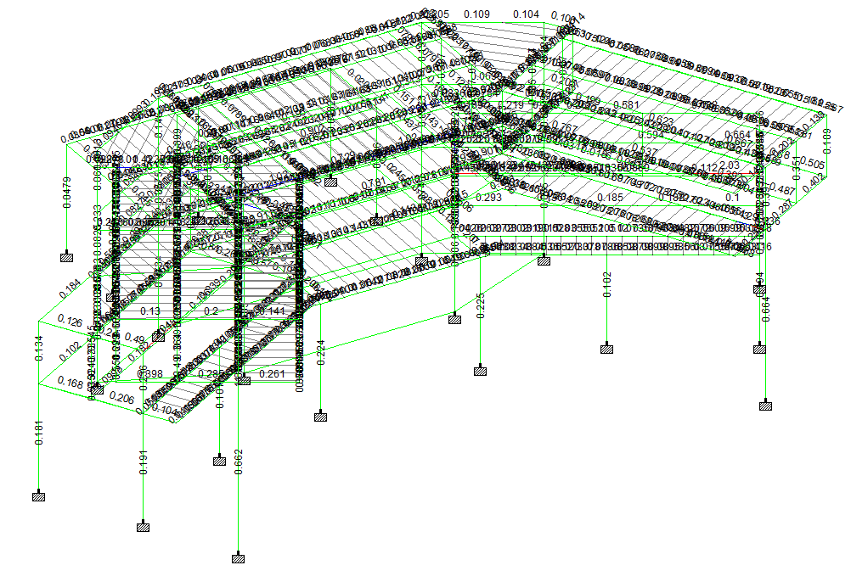

**UNITY RATIOS – Isometric View**

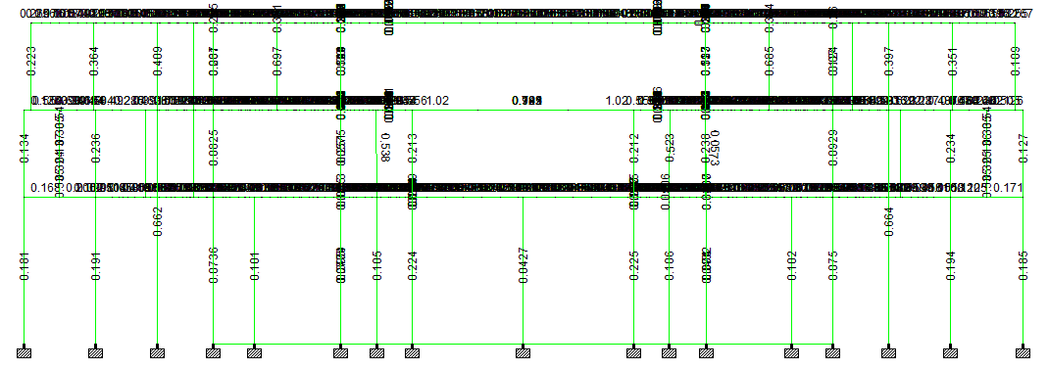

**UNITY RATIOS – Front View**

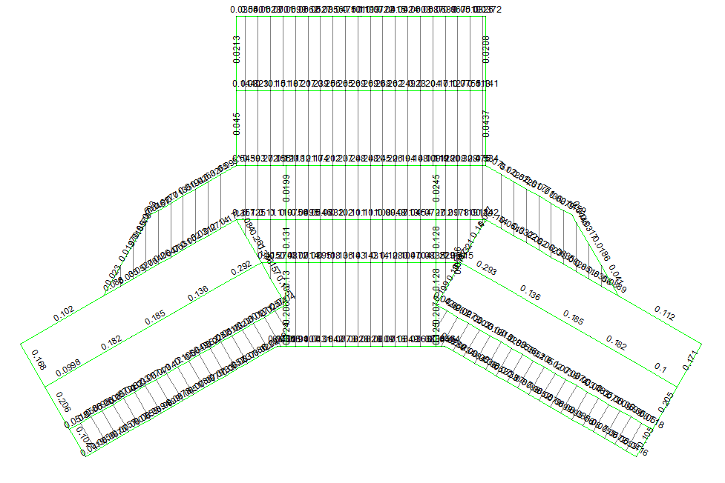

**UNITY RATIOS – First Floor Plan View**

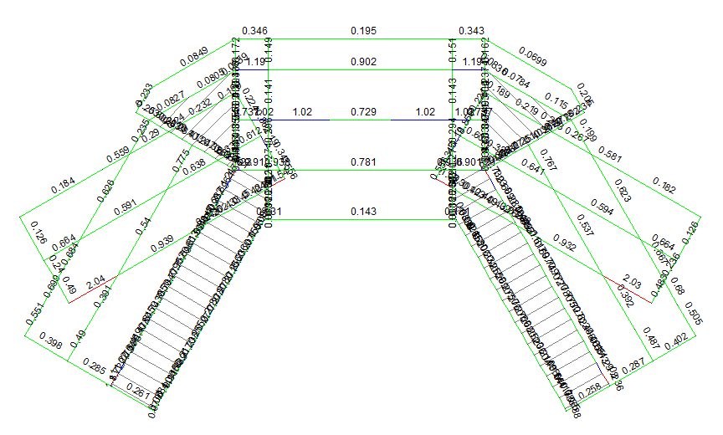

**UNITY RATIOS – Second Floor Plan View**

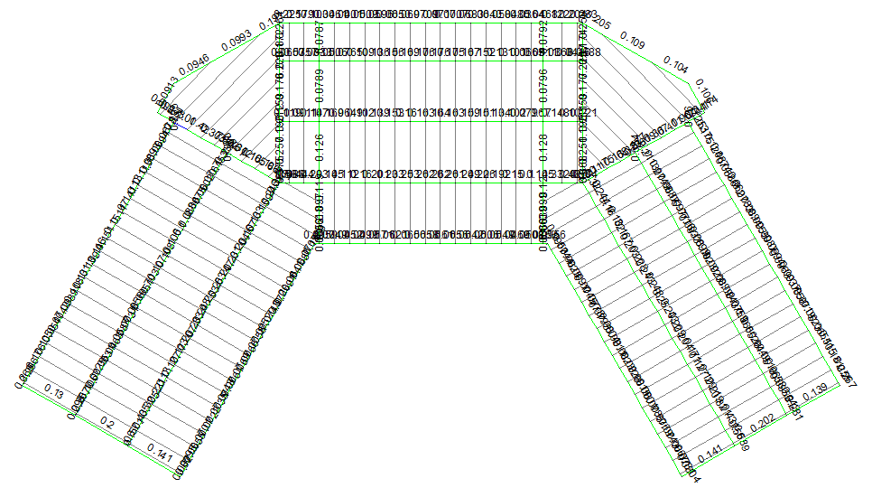

**UNITY RATIOS – Roof Plan View**

# CHECK FOR SERVICEABILITY

|  |  |  |  |  |  |  |  |  |  |  |
| --- | --- | --- | --- | --- | --- | --- | --- | --- | --- | --- |
|  |  |  | Horizontal | Vertical | Horizontal | Resultant | Rotational | | | |
|  | Node | L/C | X in | Y in | Z in | in | rX rad | rY rad | rZ rad |
| Max X | 111 | 230 DL+W(+X) | 0.79 | -0.07 | 0.42 | 0.9 | -0.001 | 0.001 | -0.001 |
| Min X | 129 | 231 DL+W(-X) | -0.79 | -0.06 | 0.42 | 0.9 | -0.001 | -0.001 | 0.001 |
| Max Y | 274 | 209 DL+W(-Z) | 0.65 | 0.15 | -0.45 | 0.8 | -0.004 | 0 | 0 |
| Min Y | 227 | 216 DL+W(+X)+LLF+LLR | 0.23 | -1.82 | 0.2 | 1.84 | -0.009 | 0.002 | 0.018 |
| Max Z | 106 | 206 DL+W(+X) | 0.76 | -0.02 | 0.47 | 0.89 | 0 | 0 | 0.001 |
| Min Z | 270 | 209 DL+W(-Z) | 0.64 | -0.02 | -0.47 | 0.79 | -0.001 | 0 | -0.002 |
| Max rX | 213 | 229 DL+E(-Y)+LLF+SN | 0 | -1.43 | 0.06 | 1.44 | 0.016 | 0.001 | 0.013 |
| Min rX | 237 | 219 DL+W(-Z)+LLF+LLR | -0.25 | -1.34 | -0.07 | 1.36 | -0.026 | -0.002 | -0.001 |
| Max rY | 114 | 206 DL+W(+X) | 0.37 | -0.11 | 0.21 | 0.43 | 0.002 | 0.008 | 0.001 |
| Min rY | 130 | 207 DL+W(-X) | -0.36 | -0.1 | 0.2 | 0.43 | 0.002 | -0.008 | -0.001 |
| Max rZ | 226 | 219 DL+W(-Z)+LLF+LLR | -0.03 | -1.18 | -0.01 | 1.18 | -0.016 | -0.002 | 0.028 |
| Min rZ | 170 | 219 DL+W(-Z)+LLF+LLR | 0.04 | -1.16 | -0.01 | 1.16 | -0.016 | 0.002 | -0.027 |
| Max Rst | 227 | 216 DL+W(+X)+LLF+LLR | 0.23 | -1.82 | 0.2 | 1.84 | -0.009 | 0.002 | 0.018 |

**Maximum Deflection in Vertical direction at node 227 for load case 216 = 1.82 in**

**Max. Allowable Local Vertical deflection= 480/240**

**= 2.0 in > 1.82 in …….... Hence OK**

# SUPPORTING NODES

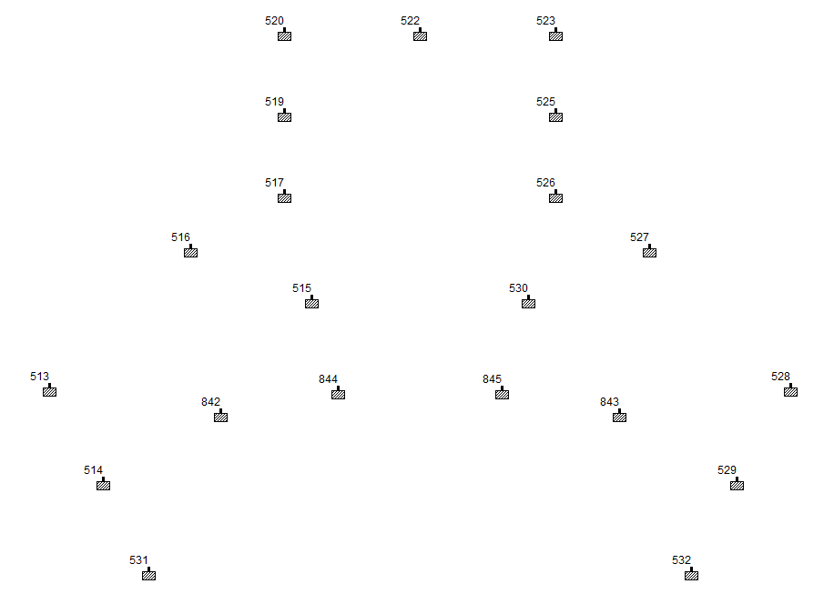

**Support Nodes**

# Support Reaction for Foundation

**Summary of Support Reaction for Foundation and Anchor Design: -**

|  |  |  |  |  |  |  |  |  |
| --- | --- | --- | --- | --- | --- | --- | --- | --- |
|  |  |  | Horizontal | Vertical | Horizontal | Moment |  |  |
|  | Node | L/C | Fx lbf | Fy lbf | Fz lbf | Mx lb-ft | My lb-ft | Mz lb-ft |
| Max Fx | 526 | 209 DL+W(-Z) | **14198** | 64297 | 9441 | -11007 | 0 | -153157 |
| Min Fx | 517 | 209 DL+W(-Z) | **-14961** | 64220 | 9487 | -9241 | 0 | 157266 |
| Max Fy | 515 | 218 DL+W(+Z)+LLF+LLR | -3936 | **82726** | -1074 | 39847 | -1 | 99640 |
| Min Fy | 517 | 232 DL+W(+Z) | 9184 | **-11019** | -9057 | -11816 | 2 | -16804 |
| Max Fz | 527 | 233 DL+W(-Z) | -4313 | 5891 | **10976** | 5185 | 2 | -10603 |
| Min Fz | 516 | 208 DL+W(+Z) | 8415 | 41439 | **-12611** | -24805 | 1 | 50317 |
| Max Mx | 530 | 218 DL+W(+Z)+LLF+LLR | 4758 | 81946 | -1201 | **39942** | 1 | -99859 |
| Min Mx | 527 | 218 DL+W(+Z)+LLF+LLR | -13943 | 56217 | -10651 | **-36834** | 0 | -80814 |
| Max My | 517 | 218 DL+W(+Z)+LLF+LLR | 5051 | 31657 | -4240 | -24083 | **4** | 111636 |
| Min My | 526 | 218 DL+W(+Z)+LLF+LLR | -5421 | 31178 | -4306 | -26300 | **-4** | -106496 |
| Max Mz | 517 | 219 DL+W(-Z)+LLF+LLR | -12151 | 78898 | 8937 | -18108 | 2 | **219479** |
| Min Mz | 526 | 219 DL+W(-Z)+LLF+LLR | 11588 | 78553 | 8846 | -20574 | -2 | **-213723** |

|  |  |  |
| --- | --- | --- |
| Max. Load in X | **14961** | lbf |
| Max. Load in Y | **82726** | lbf |
| Max. Load in Z | **12611** | lbf |
| Max. Moment in X | **39942** | lb-ft |
| Max. Moment in Y | **4** | lb-ft |
| Max. Moment in Z | **219479** | lb-ft |

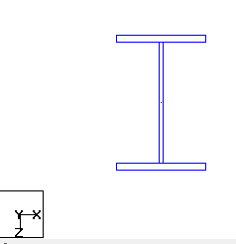

# BASE PLATE DESIGN

